 | Tuesday March 18, 2025 |  | CONVO  Strategy |  |  |  |  |  |  | Issue  #1
 | Pradyot Bathuri & CaganMeteris  Question  Why?  For individuals who have just graduated college or are entering it, the transition to the professional world can feel daunting. Many young professionals struggle with understanding how to communicate effectively in high-stakes scenarios, such as interviews, client meetings, or workplace discussions. The gap between academic knowledge and real-world application often leaves them uncertain about how to respond to questions, what to expect in professional conversations, or how to adapt their tone and mannerisms to build rapport. This lack of confidence can hinder their ability to make a strong first impression, navigate complex interactions, or advocate for themselves in competitive environments. In today’s fast-paced and interconnected world, mastering the art of professional communication is no longer optional—it’s a critical skill that can determine career growth and success.  Providing a structured yet dynamic pathway for these individuals to learn and practice professional communication is essential. Tools like an AI-driven app that simulates real-world conversations can bridge this gap by offering a safe environment for users to experiment, make mistakes, and improve. By allowing users to engage with AI personalities tailored to specific roles—such as potential employers, clients, or colleagues—the app prepares them for the unexpected twists and turns of real-life interactions. It not only helps users anticipate questions but also evaluates their responses based on key factors like tone, humility, and timing, offering actionable feedback for improvement. For students and recent graduates who may lack access to mentors or real-world experience, such tools can serve as a transformative resource, equipping them with the confidence and skills needed to excel in their professional journeys. |  |  |  |  | 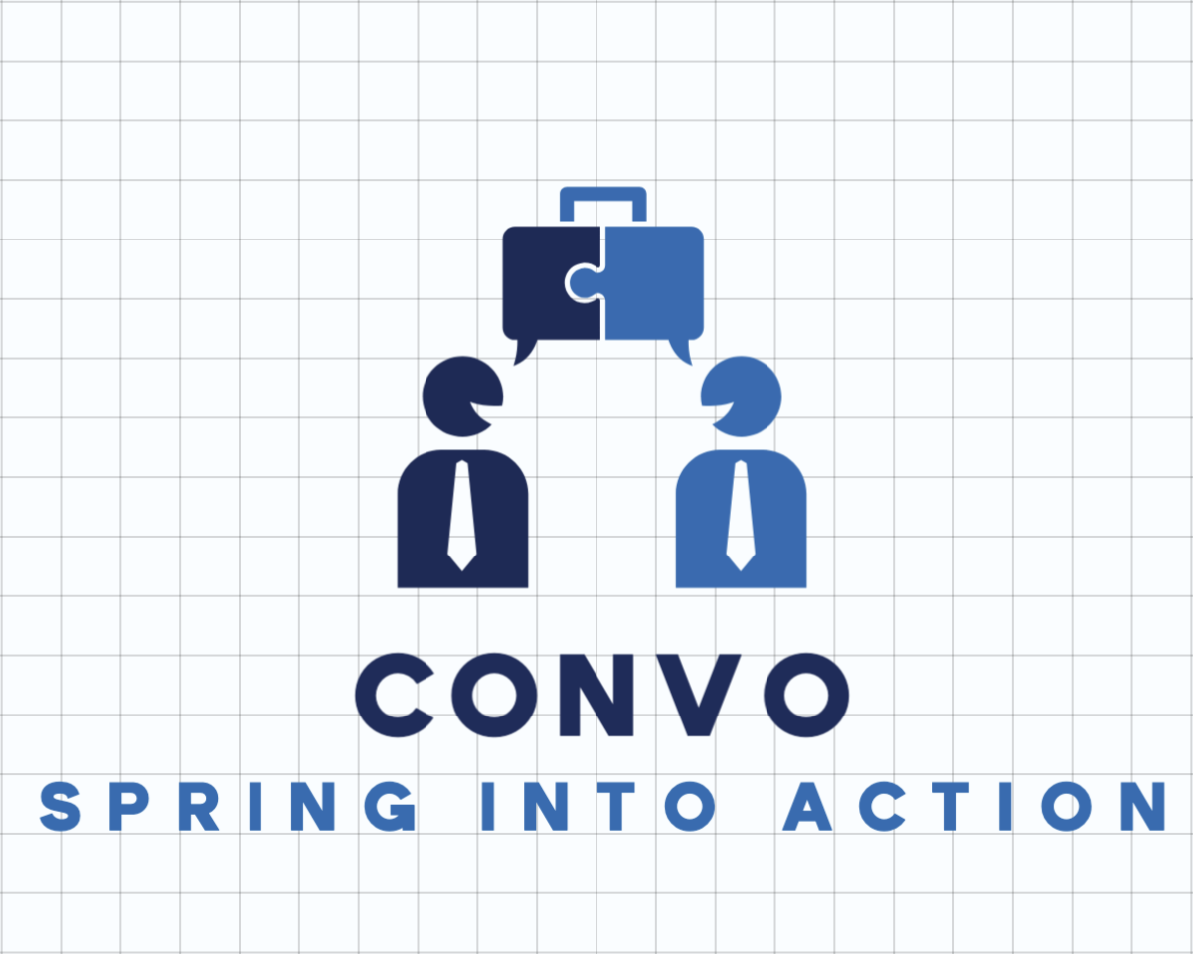
Statistics
The Market and Demand

 |  |  |  |  |  | The general population, particularly students and young professionals, is likely to find an app that simulates professional conversations with AI appealing due to its ability to address common challenges in communication and career readiness.  Research shows that 86% of students globally are already using AI tools in their studies, with 54% utilizing them on a weekly basis. However, many students (58%) report feeling inadequately prepared for an AI-enabled workplace. This indicates a strong demand for tools that not only enhance learning but also provide practical applications for professional development. An app that helps users practice marketing communication and adapt to dynamic conversations could fill this gap by offering personalized, interactive learning experiences.  Such tools align with trends in AI adoption, where personalization and efficiency are key drivers of engagement. Additionally, AI's ability to analyze user responses and provide actionable feedback would appeal to individuals seeking to build confidence in their communication skills. |  | Academic statistics further highlight the appeal of AI-driven educational tools. For example, nearly three-fourths (74%) of high school students believe their academic performance improves when using AI for assignments. Similarly, over two-thirds of college students report using generative AI tools like ChatGPT for information searching and concept explanation.  These findings suggest that users value AI’s ability to enhance learning outcomes and simplify complex tasks. Moreover, the global AI market in education is projected to grow from $2.5 billion in 2022 to $6 billion by 2025, reflecting increasing demand for innovative AI solutions. By leveraging these insights, an app focused on simulating real-world marketing conversations would not only cater to the needs of students and professionals but also capitalize on the growing acceptance of AI as a transformative tool in education and career preparation.
 | 
Tuesday March 18, 2025 |  | Vision |  |  |  |  |  |  | Issue #1
Defining the idea of Confidence
The latest updates to get you through the day at work
Designed to help users master marketing and conversational skills in a dynamic, AI-driven environment. By combining elements of role-playing, real-world simulation, and tailored learning, it prepares users for various professional scenarios in ways that traditional apps cannot.  The app immerses users in realistic conversations with AI-generated personalities that adapt and respond dynamically, offering a unique tool for skill-building. Whether preparing for a negotiation, pitching ideas in a boardroom, or navigating team discussions, users can engage with AI personalities tailored to specific industries or roles, making the learning experience highly relevant and impactful. |  |  |  | What sets this app apart are its innovative differentiators and features.  Users can prompt the AI to emulate specific individuals—such as a real estate buyer or board member—creating personalized interactions that simulate real-world dialogue. AI personalities interrupt, question, and respond based on user input, enabling users to practice dynamic conversations and decision-making scenarios.  The app offers customizable difficulty levels, allowing users to set conversation durations (from one minute to an hour) and adjust complexity on the fly. Unique multi-person simulations enable users to add multiple AI personalities for group settings like board meetings. |  |  | Additionally, voice and context integration enhances personality accuracy by leveraging user-provided data such as LinkedIn profiles or voice prompts. Features like real-time feedback on tone, humility, response time, and effectiveness provide actionable insights for improvement. Flexible learning paths ensure adaptability, while voice inputs refine AI responses for greater realism. This comprehensive approach makes the app an invaluable resource for mastering professional communication and excelling in diverse scenarios.  
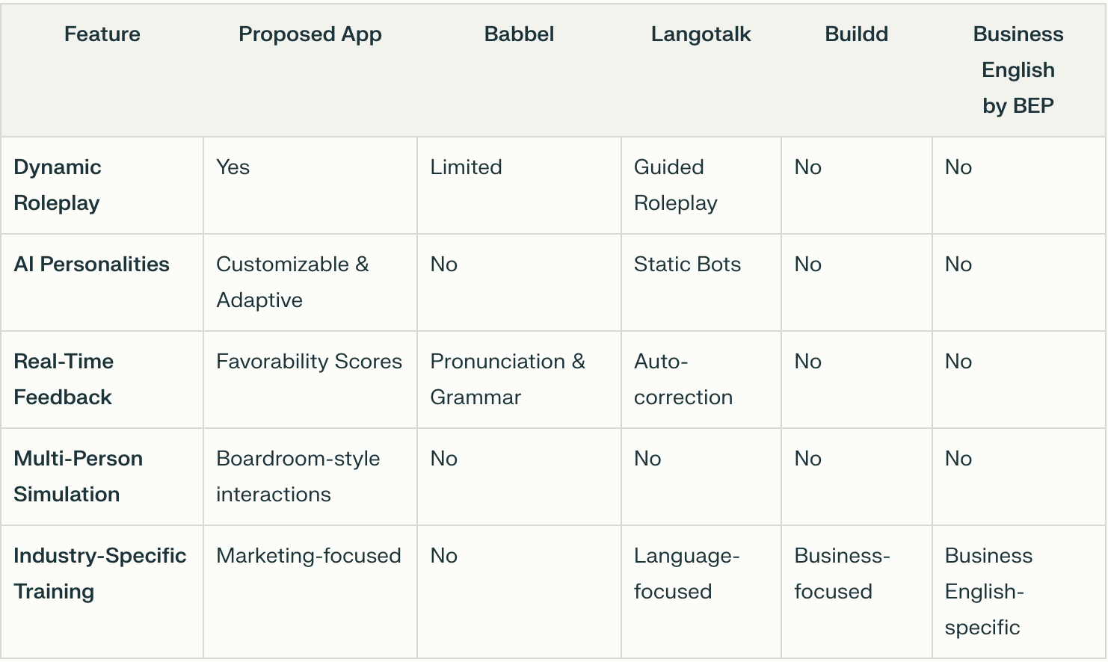 |  |  |  |  |  |  | Babbel: Babbel’s focus on real-life conversations and speech recognition inspired the idea of interactive dialogues tailored for marketing scenarios.  Langotalk: Its use of AI bots for language learning demonstrates the potential of AI-driven interaction in education.  Buildd: Buildd’s bite-sized lessons and personalized learning paths influenced the idea of flexible session lengths and adaptive feedback48.  Business English by BEP: Its focus on professional scenarios like meetings and negotiations aligns with the app’s goal of preparing users for real-world challenges.
What makes Convo different

Addressing Challenges
One major hurdle is developing an accurate personality processor capable of simulating realistic behaviors based on limited data inputs (e.g., LinkedIn profiles).
To overcome this:
Integrate advanced natural language processing (NLP) models capable of analyzing user-provided data and generating nuanced responses.
Allow optional voice prompts for users to provide context about their goals, which will refine personality simulations.
Continuously train AI models using diverse datasets to improve adaptability across industries.

What sets this app apart from existing solutions is its ability to:
Simulate Realistic Personalities: Users can prompt the AI to act as specific individuals (e.g., a real estate buyer or board member), creating highly relevant and personalized interactions.
Dynamic Conversations: The AI personalities interrupt, question, and respond based on user input, simulating real-world dialogue and decision-making scenarios.
Customizable Difficulty: Users can set conversation timers (from one minute to an hour) and adjust difficulty levels on the fly, tailoring the experience to their needs.
Multi-Person Simulations: Unique functionality allows users to add multiple AI personalities to simulate group settings like board meetings or team discussions.
Voice and Context Integration: The app leverages user-provided data (e.g., LinkedIn profiles or voice prompts) to enhance personality accuracy and adapt conversations based on the user's goals and circumstances.

Features
Role-Specific Training:
Users can train for specific roles by simulating conversations with AI personalities tailored to their industry or scenario.
For example, preparing for a negotiation with a prospective buyer or pitching ideas in a boardroom.
Real-Time Feedback: The app evaluates user responses based on factors like tone, humility, response time, and effectiveness.
Feedback includes scores on favorability and actionable tips for improvement.
Flexible Learning Paths: Users can choose between short sessions or extended practice periods.
Manual adjustments during conversations ensure adaptability.
Voice Prompt Integration: Voice input allows users to provide context about their goals, standing, or intended outcomes.
This information fine-tunes AI responses for greater realism.
Group Dynamics Simulation: Simulate multi-person interactions with diverse personalities, ideal for preparing for team meetings or stakeholder discussions.

